|  |
| --- |
| Direct HR |
| Online Meetings Database Logs |
| How it works |
|  |
| **Vincent Qiu** |
| **2012/8/15** |

|  |
| --- |
| [在此处键入文档摘要。摘要通常为文档内容的简短概括。在此处键入文档摘要。摘要通常为文档内容的简短概括。] |

目录

Online Meetings Database Logs 1

Database 1

Get status of BBB (Big Blue Button) 1

Recording user status (in and out) 1

Each Database 2

OnlineMeeting 2

MeetingLogs 2

LoginStatus 2

Online Meetings Database Logs

# Database

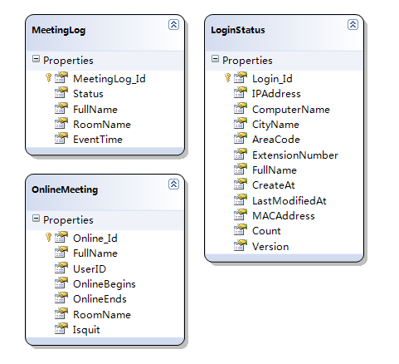

# Get status of BBB (Big Blue Button)

The data comes from BBB’s demo jsp page (in our BBB server): **demo/demo4_helper.jsp**

The page will return a xml styled data of who is online and which meeting room has been open.

# Recording user status (in and out)

To record the status of online users, the program must compare the data from online data real time. The Program set compare the data every 5 seconds, and the user who are not online for 2 minutes will be marked as offline.

# Each Database

## OnlineMeeting

This database is using compare the data with BBB’s online users status, every sign in and sign out will be found and user data will be put into this database.

Program will check the BBB’s user online status and put the new information to this database for next compare.

Online_Id: Auto Number

FullName: Full name of logged in user.

UserID: The string BBB generated, each user and meeting room are different.

OnlineBegins: The first time program found the new user (this session) in meeting room.

OnlineEnds: The last time program found the user (this session) in meeting room.

RoomName: Room name of meeting room.

Isquit: If the user quit the meeting room, this filed will be mark as true, and it means this session of the user has been terminated.

## MeetingLogs

This database record the time of one user sign out and sign in meeting room.

Once a new record put into **OnlineMeeting** database, a new record also will be put into this database and the data will be marked as user sign in.

If one user in **OnlineMeeting** database’s **OnlineEnds** time is not changed for 2 minutes and **Isquit** is false, a new record of user sign out will be put into this database, this user data in **OnlineMeeting** will be marked **Isquit** (true).

MeetingLog_Id: Auto increase number.

Status: 1 means sign in, -1 means sign out.

FullName: Full name of the user.

RoomName: Room name of the meeting room of this user.

EventTime: If sign out, the time will same as **OnlineEnds** in **OnlineMeeting**. If sign in, the time will be the same as **OnlineBegins**.

## LoginStatus

The data in this database are using for Soft phone agent online status. Soft phone agent will upload the simply data of username, computer name, program version etc. to the database.